To: | City Executive Board
Date: | 22 January 2019
Report of: | Acting Head of Planning Services
Title of Report: | Oxfordshire Plan 2050 Statement of Community Involvement; Amendment to the Local Development Plan and Regulation 18 Part 1 Consultation Document

Summary and recommendations
Purpose of report: |  | The purpose of this report is to seek approvals to progress the production of the Oxfordshire Plan 2050 through adopting the Statement of Community Involvement, approving an amendment to the Local Development Scheme and approving the Regulation 18 (Part 1) document for consultation.
Key decision: |  | Yes
Executive Board Member: |  | Councillor Alex Hollingsworth, Board Member for Planning
Corporate Priority: |  | A Vibrant and Sustainable Economy; Meeting Housing Needs; Strong and Active Communities; A Clean and Green Oxford
Policy Framework: |  | None.
Recommendations:That the City Executive Board resolves to:
1. | Adopt the Statement of Community Involvement (“SCI”) as amended following the close of the consultation as attached at Appendix 1;
2. | Approve the amendment to the Local Development Scheme (“LDS”) as as set out at paragraph 18 of this report;
3.  4. | Approve the Regulation 18 (Part 1) Issues consultation document for public consultation as attached at Appendix 3; and  Authorise the Oxfordshire Councils joint Heads of Planning group, to make any necessary editorial corrections and minor amendments to the documents, and to agree the final publication style

Appendices
Appendix 1 | Statement of Community Involvement and schedule of amendments
Appendix 2 | Regulation 18 (Part 1) Issues consultation document
Appendix 3  Appendix 4 | Risk Register  Equalities Impact Assessment

Purpose
The purpose of this report is to seek approvals to progress the production of the Oxfordshire Plan 2050 through adopting the Statement of Community Involvement, approving an amendment to the Local Development Scheme and approving the Regulation 18 (Part 1) document for consultation.

Introduction and background
The six Oxfordshire Councils (four Districts, one City and the County Council) and the Oxfordshire Local Enterprise Partnership (OXLEP) have agreed the Oxfordshire Housing and Growth Deal (“the Growth Deal”) with Government. Under the terms of the Growth Deal, the Local Planning Authorities have committed to producing an Oxfordshire Joint Statutory Spatial Plan (the “Plan”) for submission to the Planning Inspectorate for independent examination by 31 March 2020 and adoption by 31 March 2021, subject to examination process.
When the councils agreed the Growth Deal through Council meetings in February 2018, one of the resolutions was to participate in the preparation of a Joint Statutory Spatial Plan to the timescales set out in the Growth Deal Delivery Plan and in accordance with Section 28 of the Planning and Compulsory Purchase Act 2004 (as amended) (“PCPA 2004”).
The Plan will provide an Oxfordshire-wide, integrated strategic planning framework and supporting evidence base to support sustainable growth across the county to 2050, including the planned delivery of the new homes and economic development, and the anticipated supporting infrastructure needed.
The Plan will be a formal Development Plan Document (DPD), prepared under Section28 of the PCPA 2004 which enables two or more local planning authorities to agree to prepare a joint Plan. Oxfordshire County Council will support the plan preparation process. The diagram below shows the Plan’s relationship with other documents and strategies
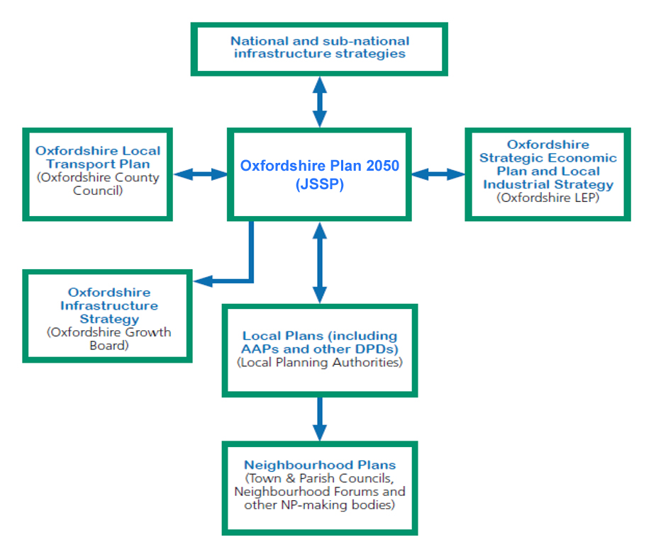

The scope of the Plan was agreed by all six Council’s in Sept/Oct 2018. Further detail on the scope, policy context, structure, evidence base, links to other work programmes and governance arrangements of the Plan can be found in the Oxfordshire JSSP Scoping Document (Background Paper 1) which was approved by all the Oxfordshire Councils during Sep/Oct 2018.

The Statement of Community Involvement (SCI)
This report recommends adoption of the SCI with any amendments made as a result of the consultation which took place between 30 Nov 2018 and 11 Jan 2019 (see Appendix 1).
The SCI is a requirement of Section 18 of the PCPA 2004. It needs to comply with statutory requirements and Government policy for plan making and consultation on planning matters.
The SCI clearly sets out the key stages for preparing the Oxfordshire Plan and how the Oxfordshire LPAs intend to inform, involve and consult stakeholders on the preparation of the plan. It will set out what is required from the partner authorities, how and when. This SCI only relates to, and is specific to, the production of the Oxfordshire Plan. The partner LPAs will also have their own individual SCIs concerned with the production of their individual Local Plans and other planning matters.
The SCI for the Plan will ensure that the plan is shaped by early, proportionate and meaningful engagement between plan makers and communities, local organisations, businesses, infrastructure providers and statutory consultees.

Local Development Scheme (LDS)
This report recommends an amendment to the LDS timetable for the Oxfordshire Plan, namely an additional consultation at Regulation 18 stage. It does not however affect the overall timetable.
Section 15 of the PCPA 2004 requires Local Planning Authorities to prepare and maintain an LDS setting out a timetable for the production of DPDs. The LDS must specify the timetable for the preparation and revision of the DPDs.
The LDS will be used by officers, consultees, developers, agents and the public in determining when important milestones in the production of the Oxfordshire Plan and key stages of consultation can be expected. Implementation of the LDS will be monitored and periodically reviewed if there are significant changes in circumstances.
The LDS was approved by all Oxfordshire Councils during Sept/Oct 2018. However, since then, considerable thought has gone into the approach towards the consultation stages. The aim is for the Plan making process to maximise engagement, interest and hopefully ‘buy-in’ for the Plan. The Plan should also seek to be enriched by the consultation process from the wealth of interest and suggestions that will emerge.
The key to effective consultation on this Plan will be to explain the narrative of the Plan clearly so that interested groups can think about the reasons for the vision, aspirations and objectives of the Plan, There is a danger that launching into broad locations for growth would distract from the critical overarching discussions around housing need and growth aspirations of Oxfordshire.
The proposal is therefore to have two Regulation 18 consultations where the first is an accessible discussion document concerning vision, aspirations objectives, and spatial scenario typologies, whereas the second consultation would look at broad locations forgrowth.
The timetable below demonstrates how two Regulation 18 consultations can be accommodated without affecting the overall timetable of the Plan’s production.
The revised key milestones for production of the Oxfordshire Plan are proposed as follows (new text in bold). This would replace the table at paragraph 16 of the LDS.

Early stakeholder engagement | Commenced
Consultation on Issues (Vision, objectives and level of growth) (Reg 18 Part 1) | Feb/Mar 2019
Consultation on Issues (Broad locations for growth) (Reg 18 Part 2) | Jun/Jul/Aug 2019
Consultation on Proposed Submission Draft Plan (Reg.19) | Oct/Nov/Dec 2019
Submission (Reg.22) | Mar 2020
Examination (Reg.24) | Sep 2020 tbc
Receipt and Publication of Inspector’s Report | Dec 2020 tbc
Adoption (Reg.26) by each partner local planning authority | Mar 2021 (subject to examination)
Regulation 18 (Part 1) Issues Consultation
This report recommends approval of the Issues consultation document for the Oxfordshire Plan (see Appendix 2). Following approval of the document, it will be published for public consultation as part of the Regulation 18 requirements. This will be the first formal public consultation on the Oxfordshire Plan
The consultation document explores the context for the Plan (setting out the quality of life, economic, natural and built environment, housing, health and wellbeing and transport and movement contexts). It proposes a draft vision for the Plan and objectives, and invites comments and improvements to those.
The document also sets out 5 aspirations for the Plan:
- Improve housing availability/affordability
- Support economic growth
- Strong and healthy communities
- Protect environmental quality
- Improve connectivity and movement
Each of these aspirations would offer real benefits to future generations if embraced in the Plan. Some of them however if taken to the extreme, or taken in isolation, would also be likely to result in real issues or have knock-on impacts for other elements of the plan. As with all complex planning issues there are choices to be made and balances that need to be struck. It is likely that different degrees of these aspirations, in combination, will be required and difficult decisions need to be made between them. We are keen to explore these issues with the public so that together we can decide where the appropriate balances may lie.
The consultation document also explores the potential spatial scenarios for accommodating growth in the Plan. For example, the Plan could take any of a range of options, for example intensification of existing settlements, providing new settlements or dispersing growth or it could take a combination of these options.
The intention is to prompt discussion (among stakeholders and the public) on these aspirations and scenarios and to invite input and feedback to improve and refine the approach when taking it into the next stage of the Plan. Future stages of Plan preparation will go on to consider broad locations for growth. By focussing the conversation at this stage on the context, need and growth aspirations of Oxfordshire, this will be a vital step towards that further discussion.
The formal public consultation is programmed to be held for a period of 6 weeks in February and March concluding ahead of the purdah period for the local elections (being held in Cherwell, South Oxfordshire, Vale of White Horse and West Oxfordshire).

Financial implications
- As part of the Housing and Growth Deal, the government has agreed £2.5million capacity funding over three years to support the development of the Plan. The intention is to deliver the project within this funding envelope. Any costs over and above this would be subject to further agreement by the Oxfordshire Authorities.
- Any work directly commissioned by Oxford City Council will be claimed back from the capacity fund held by the County Council as the Accountable Body for the deal, or from other Local Plan Authorities over and above the capacity funding.

Legal issues
- The Council has a legal duty to produce an LDS and an SCI under sections 15 and 18 respectively of the PCPA 2004 and to carry out early engagement on the content of the Plan under Regulation 18 of The Town and County Planning (Local Planning) (England) Regulations (2012).

Level of risk
- A Risk Register is attached as Appendix 3.

Equalities impact
- A two-stage approach to the Equality Impact Assessments (EqIA) is being followed for the Local Plan project. The first phase comprises of an initial assessment of the policy areas within the consultation document (attached as Appendix 4). Views on this assessment will be sought as part the Regulation 18 consultation.
- The second phase of the EQIA will look at the policies as they will be drafted in the Proposed Submission Document. Consultation on that phase of the EqIA will be combined with the next round of public engagement for Regulation 19.

Report author | Carolyn Ploszynski
Job title | Planning Policy and Design, Conservation and Trees Manager
Service area or department | Planning, Sustainable Development & Regulatory Services
e-mail | CPLOSZYNSKI@oxford.gov.uk

Background Papers:
1 | Oxfordshire Joint Statutory Spatial Plan Scoping Document

